Comparative Genomics 2018
Practical 2: Gene prediction
Group number: 6
Group members: Kyle Kimler, Kajetan Juszczak

Summary

All of the latest search tools provide users with functions like coding sequence identification, and other useful tools. Coding sequence identification in particular is very useful these days, in the era of metagenomics. We can imagine so many uses for computational DNA/protein identification. For example, if we find a species with some extraordinary abilities, we can sequence its genome, pick out the genes that might have an effect on that ability, and then we can use that information to design some new biological medicines or other useful biotechnological purposes. We can also use coding sequence identification for more human purposes – lately some scientists have realized that there might be some low expressing, very short genes in the genome that were passed over in first attempts at data mining. Maybe with some tweaks to our methods, machine learning prediction, or parsers that take into account introns, we can find and better understand those genes that might provide a smaller and more exquisite control of our genomes.

- tigr-glimmer long-orfs -n -t 1.15 01.fa 01.long-orf-coords
long-orfs – in order to execute glimmer we need to build a probability model for a coding sequence. To build the model, the program build-icm is first trained on some training sequences. In this case, these sequences are gathered by tig-glimmer’s long-orfs. This program takes genome as input and outputs long non-overlapping orfs.
-n output file will not have header with program settings
-t we specify the cut-off value for entropy distance score. All the genes with scores bellow cut-off values will not be taken into consideration.
01.fa input file name
01.long-orf-coords output file name
- tigr-glimmer extract -t 01.fa 01.long-orf-coords > 01.longorf
extract – program takes both genome and output of long orfs as input and outputs multi fasta file listing parts of genome between coordinates
- t in this case specifies that output will be text file
01.fa input file name – genome
01.long-orf-coords coordinates input file
01.longorf output filename
- tigr-glimmer build-icm -r 01.icm < 01.longorf
build-icm – a program taking the output of extract as input and based on it outputs interpolated context model(ICM)
-r means that program is using not only 5’ → 3’ orfs but also 3’ → 5’ orfs for building model
01.icm output filename(model)
01.longorf input filename
- tigr-glimmer glimmer3 -o50 -g110 -t30 01.fa 01.icm 01.glimmer
glimmer3 – program that predicts genes. Takes two files as input – model and sequence to be predicted and outputs to files ‘name.predict’ and ‘name.detail’
-o50 maximum overlap between genes set to 50
-g110 minimum length of gene set to 110
-t30 sets threshold score for region. If its above the threshold the region is considered potential gene.
01.fa 01.icm inputs (sequence for which genes will be predicted and model respectively)
01.glimmer is the name of the output file. Two files will be generated each time one with .predict and one with .detail ending.
- Can be taken from some already known genes in the genome found by homology based search or genes can be taken from very similar organisms.
- It is designed for identification of genes in prokaryotic DNA. It does not take into consideration that some stop codons might be within introns so they would not terminate orf.
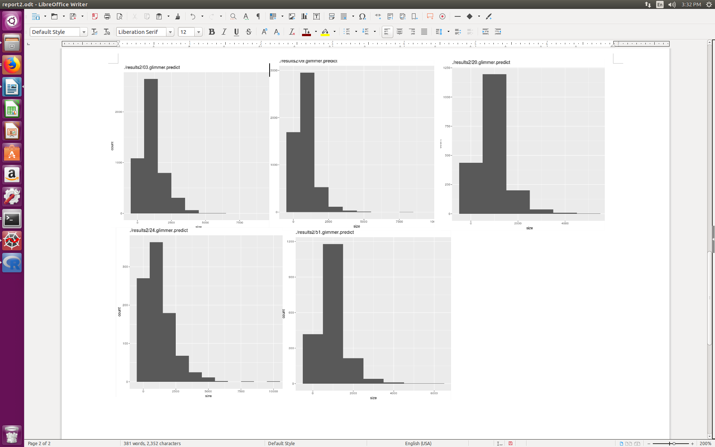
- Histograms.
** for one graph we had to remove one of the orfs since program is not debuged correctly and if gene starts before 0th nucleotide and ends after 0th nucleotide program just takes gene length as absolute value of difference between position of first and last nucleotide which results in gene length equal to almost full genome and spoil the graph by extending size axis.
- the graphs are similar in distribution. The difference can be seen in number of genes, it is significantly lower for eukaryotic organisms(4th plot – 24), because prokaryotes have to be very compact, they have a greater gene density.
- Attachment

ex.2
- Attachments
- Attachments
- Protein COS7, alpha-glucoside permease

